Create kind cluster if you want:

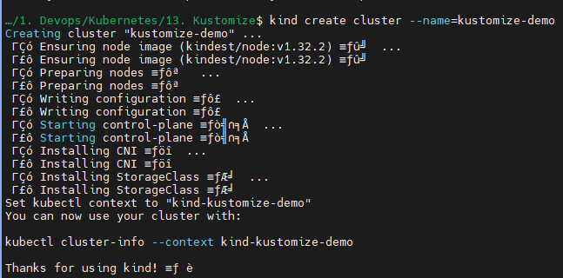

Check the current context, change if required:

* kubectl config get-contexts
* kubectl config current-context

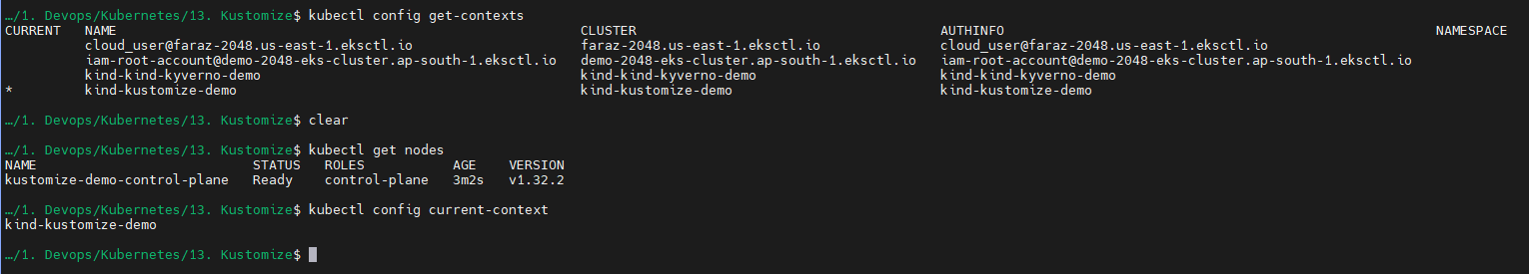

**Using inbuild transformers:**

Now create a deployment in test/base/

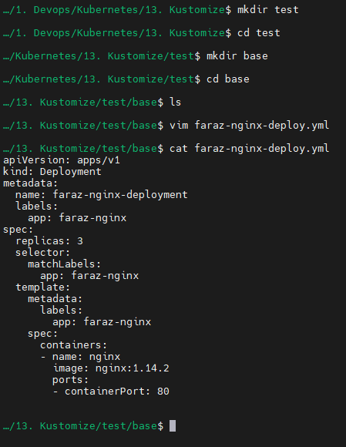

And create kustomization:

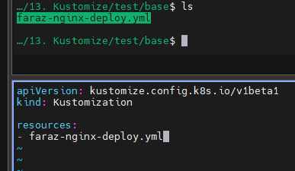

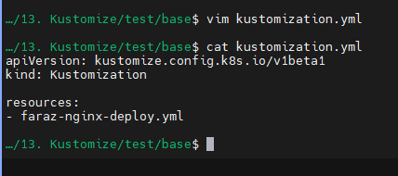

This kustomization file will keep a track of resources we want to keep a track of or modify

Now create overlays folder:

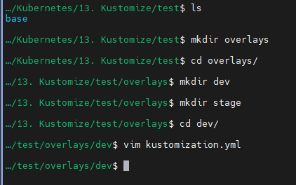

Create a kustomization file:

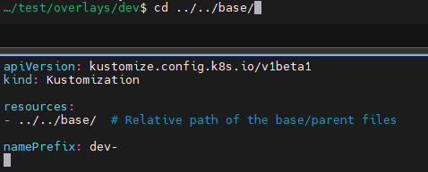

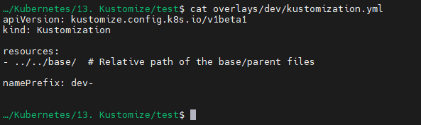

Now we kustomize:

* kubectl kustomize base/

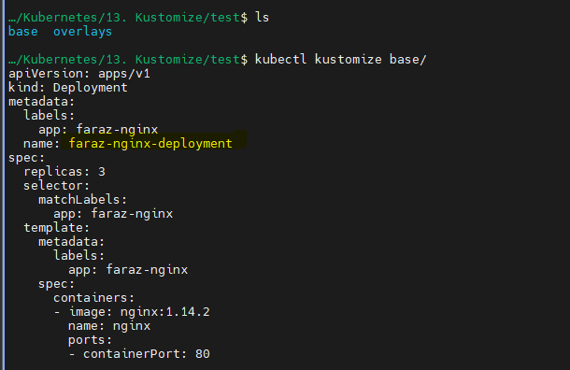

* kubectl kustomize overlays/dev/

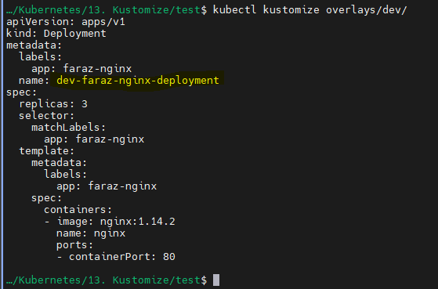

Similarly, we create for stage as well:



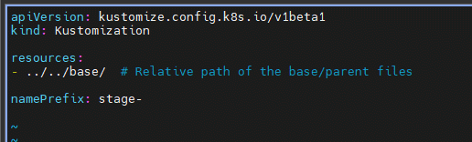

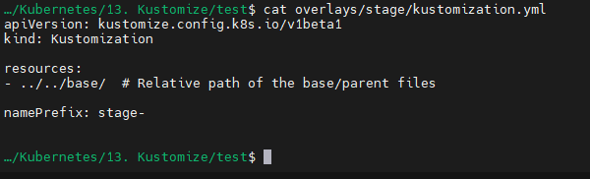

* kubectl kustomize overlays/stage/

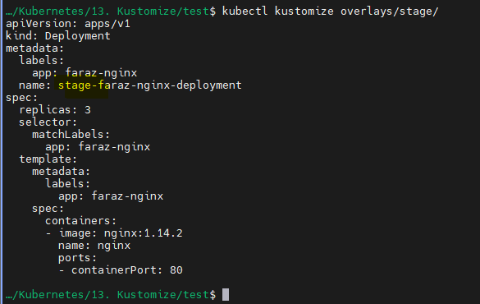

Now create namespaces:

* kubectl create ns dev-namespace
* kubectl create ns stage-namespace

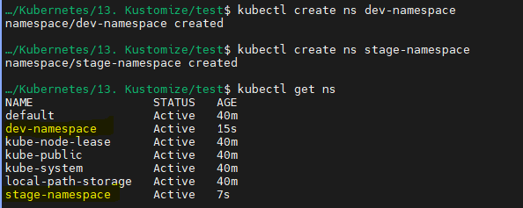

* kubectl apply -k overlays/dev/ -n dev-namespace

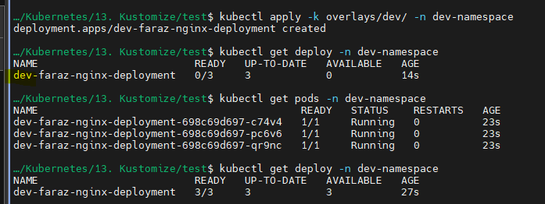

* kubectl apply -k overlays/stage/ -n stage-namespace

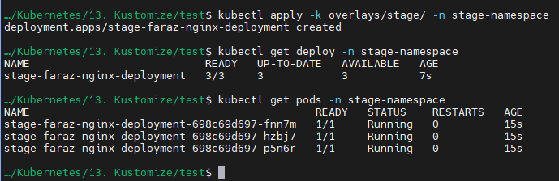

You can also kustomize the image tags:

So instead of 1.14.2 I want to use latest:

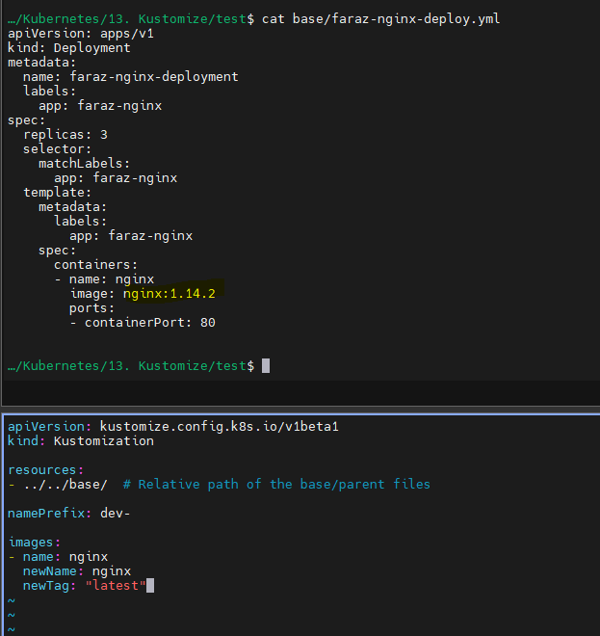

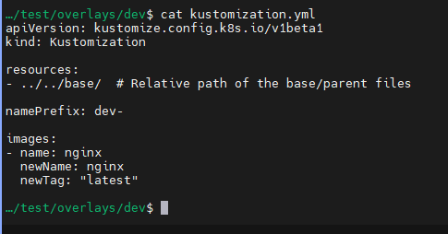

* kubectl kustomize overlays/dev

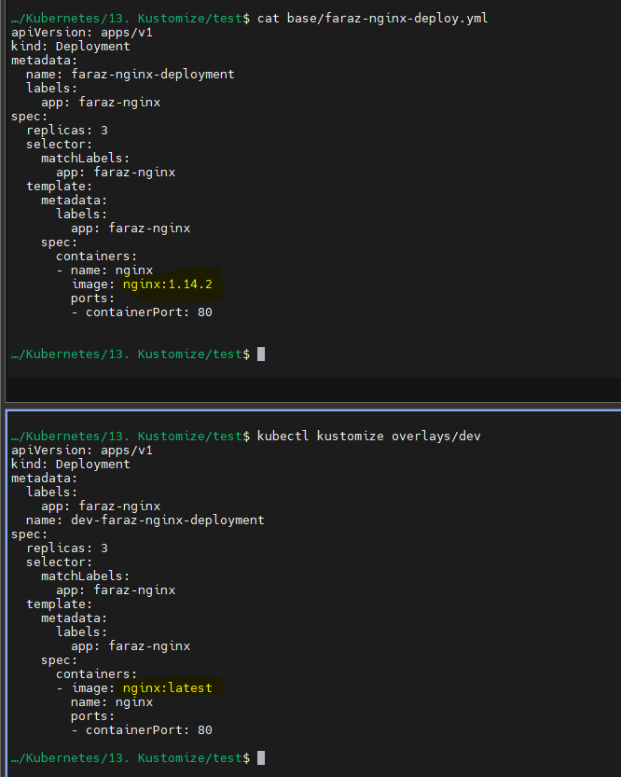

**You can also use your own patches (underlying use of transformers is same but gives more flexibility):**

2.1. We can also perform demo for replicas:

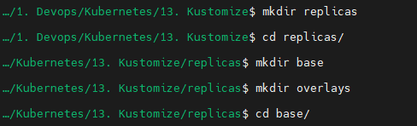

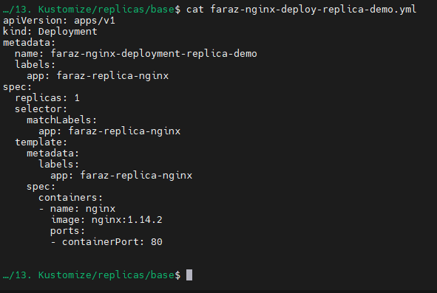

Also create base kustomization file:

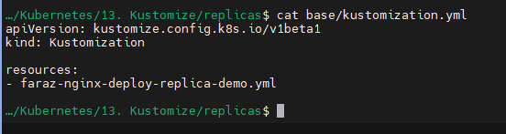

Test it by:

* kubectl kustomize base/

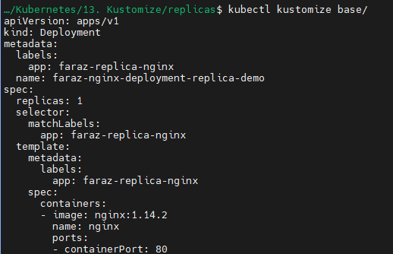

If this is successful, it means that the kubectl and kustomize were able to load the files and these files can be kustomized by anyone by overlays

Create a patch:

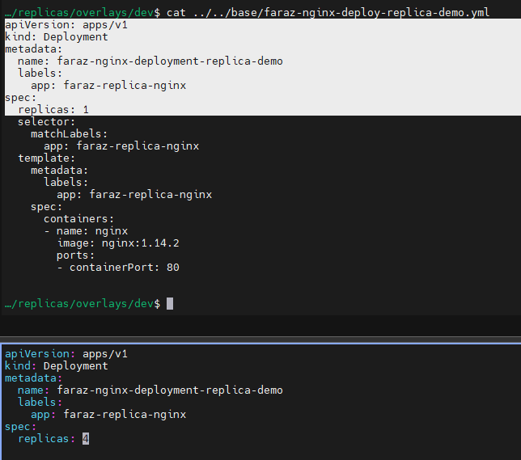

Edit the kustomization file:

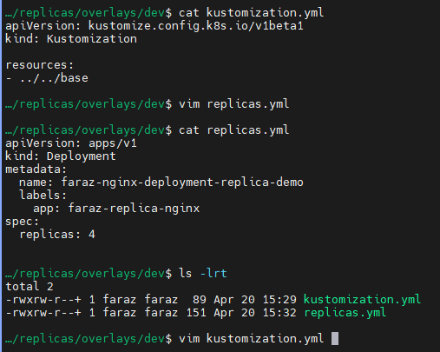

Add the patches:

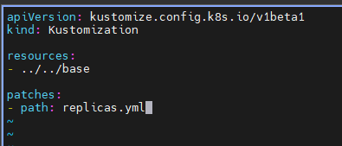

* Your kustomization file will look like this on editing:

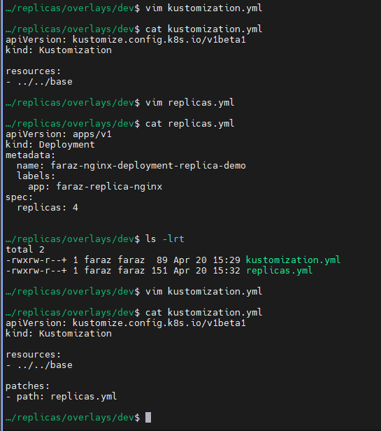

Now if you:

* kubectl kustomize base/
* kubectl kustomize overlays/dev/

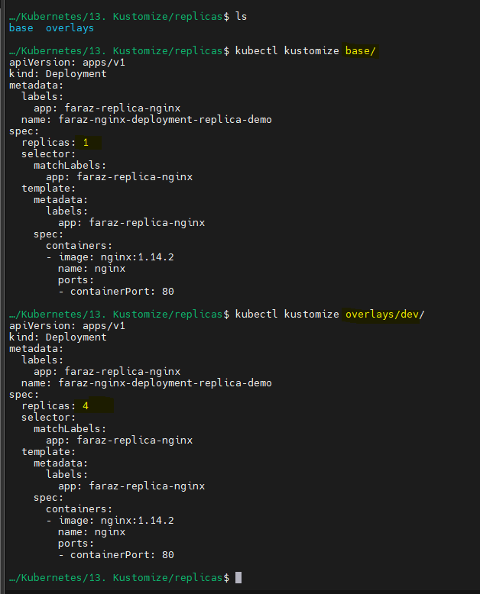

Here you will be able to compare the kustomization which we want to achieve using overlays to base.

2.2. You can also use JSON yml approach:

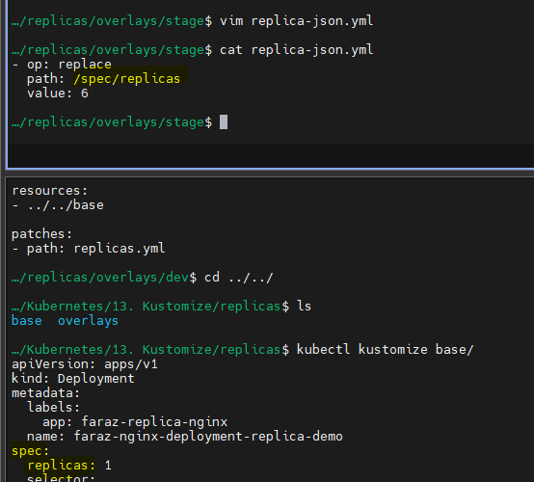

Also add the following patches and target:

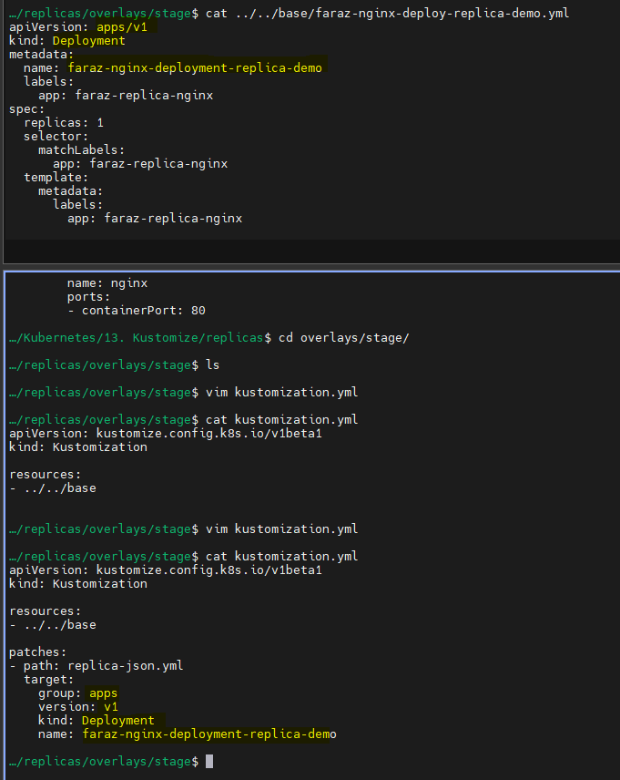

You can verify:

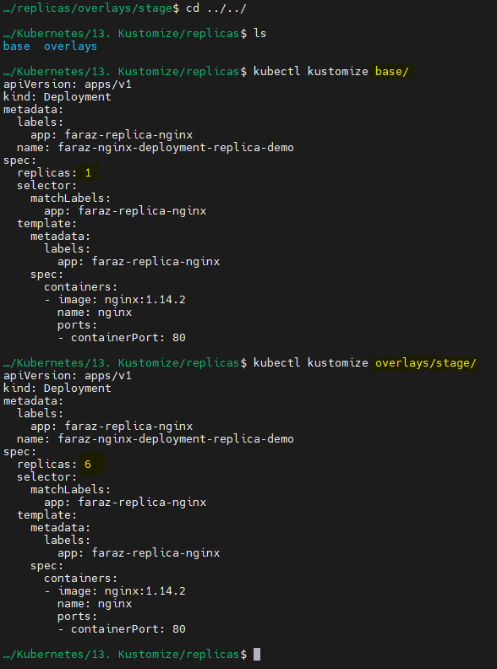

Now test it by running the kustomize:

Namespaces:

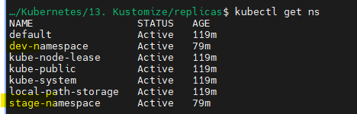

Currently we have:

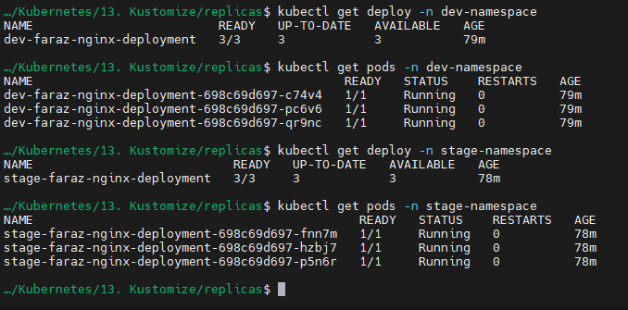

Now on applying:

* kubectl apply -k overlays/dev/ -n dev-namespace

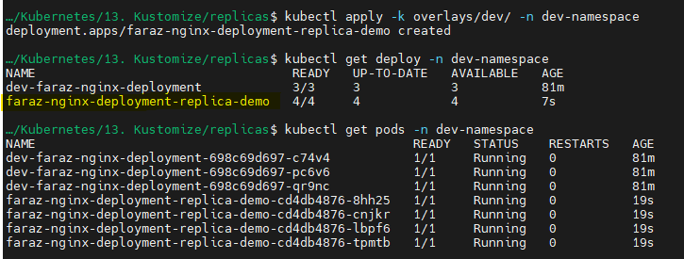

* kubectl apply -k overlays/stage/ -n stage-namespace

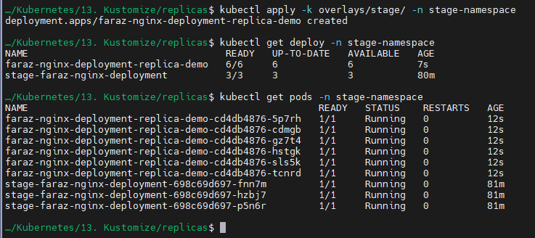

For more examples:

<https://github.com/iam-veeramalla/kustomize-zero-to-hero/tree/main>